Practical 6
Part A
1) | Remote control: an interface Switchable with on()/off() and a default toggle(); Fan and  Light implement it. Loop over a Switchable[] toggling each. Then add a functional  interface that decides, given a device and an hour, whether it may switch on, and supply it  once as an anonymous class and once as a lambda.
 | RemoteDemo.java
Code | interface Switchable {  void on();  void off();  default void toggle() { on(); off(); }  }  class Fan implements Switchable {  public void on() { System.out.println("Fan ON"); }  public void off() { System.out.println("Fan OFF"); }  }  class Light implements Switchable {  public void on() { System.out.println("Light ON"); }  public void off() { System.out.println("Light OFF"); }  }  @FunctionalInterface  interface Permission { boolean allow(Switchable device, int hour); }  public class RemoteDemo {  public static void main(String[] args) {  Switchable[] devices = {new Fan(), new Light()};  for (Switchable d : devices) { d.toggle(); }  Permission p1 = new Permission() {  public boolean allow(Switchable d, int hour) { return hour < 22; }  };  Permission p2 = (d, hour) -> hour < 22;  System.out.println(p1.allow(devices[0], 10));  System.out.println(p2.allow(devices[0], 10));  }  }
Output | 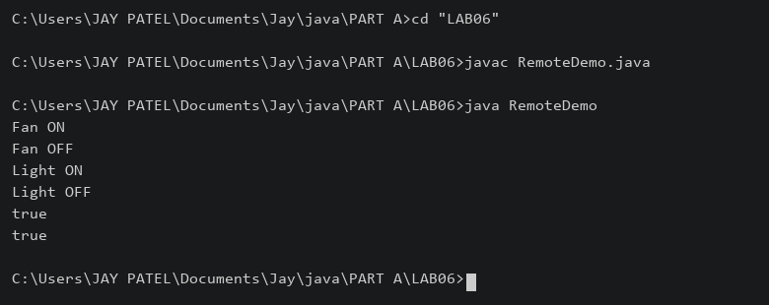

2) | Notification senders: a functional interface Notifier with send(String); make email and  SMS senders as lambdas, hold them in an array, and broadcast one message through all.  Add a marker interface Urgent and send twice for senders marked urgent.
 | NotificationDemo.java
Code | @FunctionalInterface  interface Notifier { void send(String message); }  interface Urgent {}  public class NotificationDemo {  public static void main(String[] args) {  Notifier email = message -> System.out.println("Email: " + message);  Notifier sms = (Notifier & Urgent) message -> System.out.println("SMS: " + message);  Notifier[] senders = {email, sms};  for (Notifier sender : senders) {  sender.send("Meeting at 10 AM");  if (sender instanceof Urgent) { sender.send("Meeting at 10 AM"); }  }  }  }
Output | 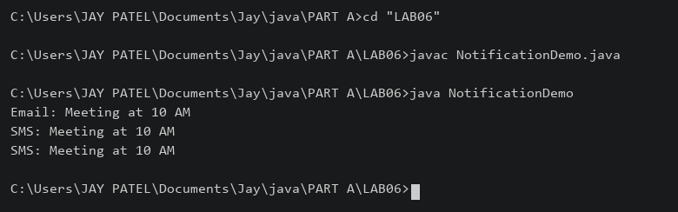

3) | (For Advanced Learners – home) Build a small discount engine where each rule is a  lambda the user picks at runtime and applies to a list of prices; organise it into packages  and ship it as a runnable JAR.
 | rules/Discount.java
Code | package rules;  @FunctionalInterface  public interface Discount { double apply(double price); }
 | app/DiscountApp.java
Code | package app;  import java.util.Scanner;  import rules.Discount;  public class DiscountApp {  public static void main(String[] args) {  double[] prices = {100, 200, 500};  Discount[] rules = {p -> p, p -> p * 0.9, p -> p * 0.8};  System.out.println("1. No discount\n2. 10% discount\n3. 20% discount");  int choice = new Scanner(System.in).nextInt();  if (choice < 1 || choice > 3) { System.out.println("Invalid choice"); return; }  Discount selected = rules[choice - 1];  for (double p : prices) { System.out.println(p + " -> " + selected.apply(p)); }  }  }
Build and run from the folder containing app and rules:
javac -d out rules/Discount.java app/DiscountApp.java
jar --create --file discount.jar --main-class app.DiscountApp -C out .
java -jar discount.jar
Output | 

